**Name and Student ID: Riley Lawson rjlawson@iastate.edu Lab Section: 6**

**Date: 9/3/2020**

**PRELAB:**

**Q1.** Read section 3.0 and fill in the truth table below for *lab2step1*. Then use it to construct the SOP expression and draw the resulting circuit using logic gates.

|  |  |  |  |
| --- | --- | --- | --- |
| **A** | **B** | **C** | **F** |
| 0 | 0 | 0 | 0 |
| 0 | 0 | 1 | 0 |
| 0 | 1 | 0 | 1 |
| 0 | 1 | 1 | 0 |
| 1 | 0 | 0 | 1 |
| 1 | 0 | 1 | 0 |
| 1 | 1 | 0 | 1 |
| 1 | 1 | 1 | 0 |

SOP Logic Expression: !AB!C + !ABC + AB!C = F

Circuit Diagram:

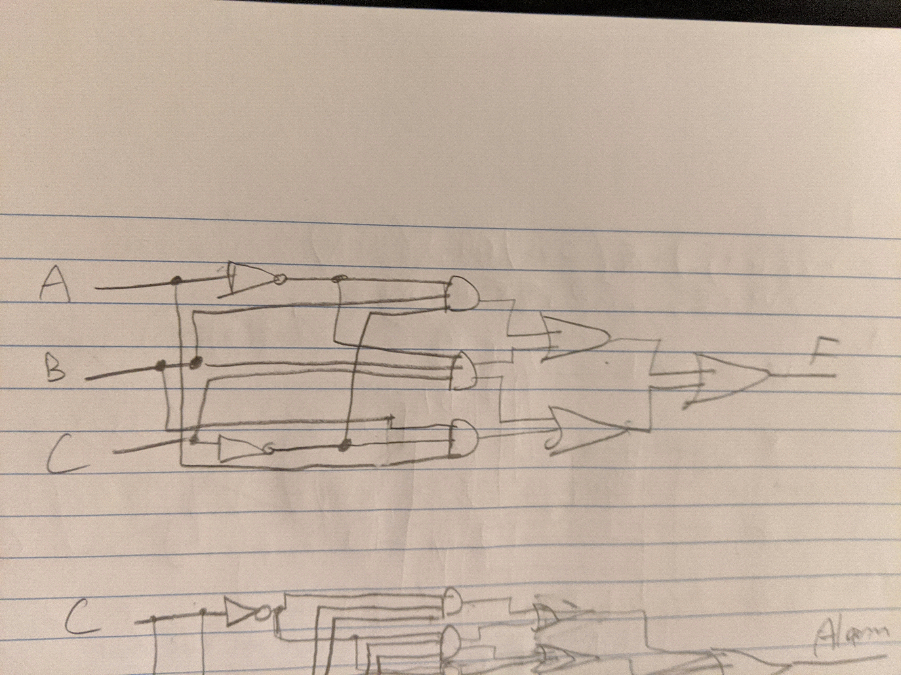

**Q2.** Read section 4.0 and fill in the truth table below for *lab2step2*. Then use it to construct the SOP expression and draw the resulting circuit using logic gates.

|  |  |  |  |
| --- | --- | --- | --- |
| **Cabbage** | **Goat** | **Wolf** | **Alarm** |
| 0 | 0 | 0 | 1 |
| 0 | 0 | 1 | 1 |
| 0 | 1 | 0 | 0 |
| 0 | 1 | 1 | 1 |
| 1 | 0 | 0 | 1 |
| 1 | 0 | 1 | 0 |
| 1 | 1 | 0 | 1 |
| 1 | 1 | 1 | 1 |

SOP Logic Expression: !C!G!F + !C!GF + !CGF + C!G!F + CG!F + CGF = Alarm

Circuit Diagram:

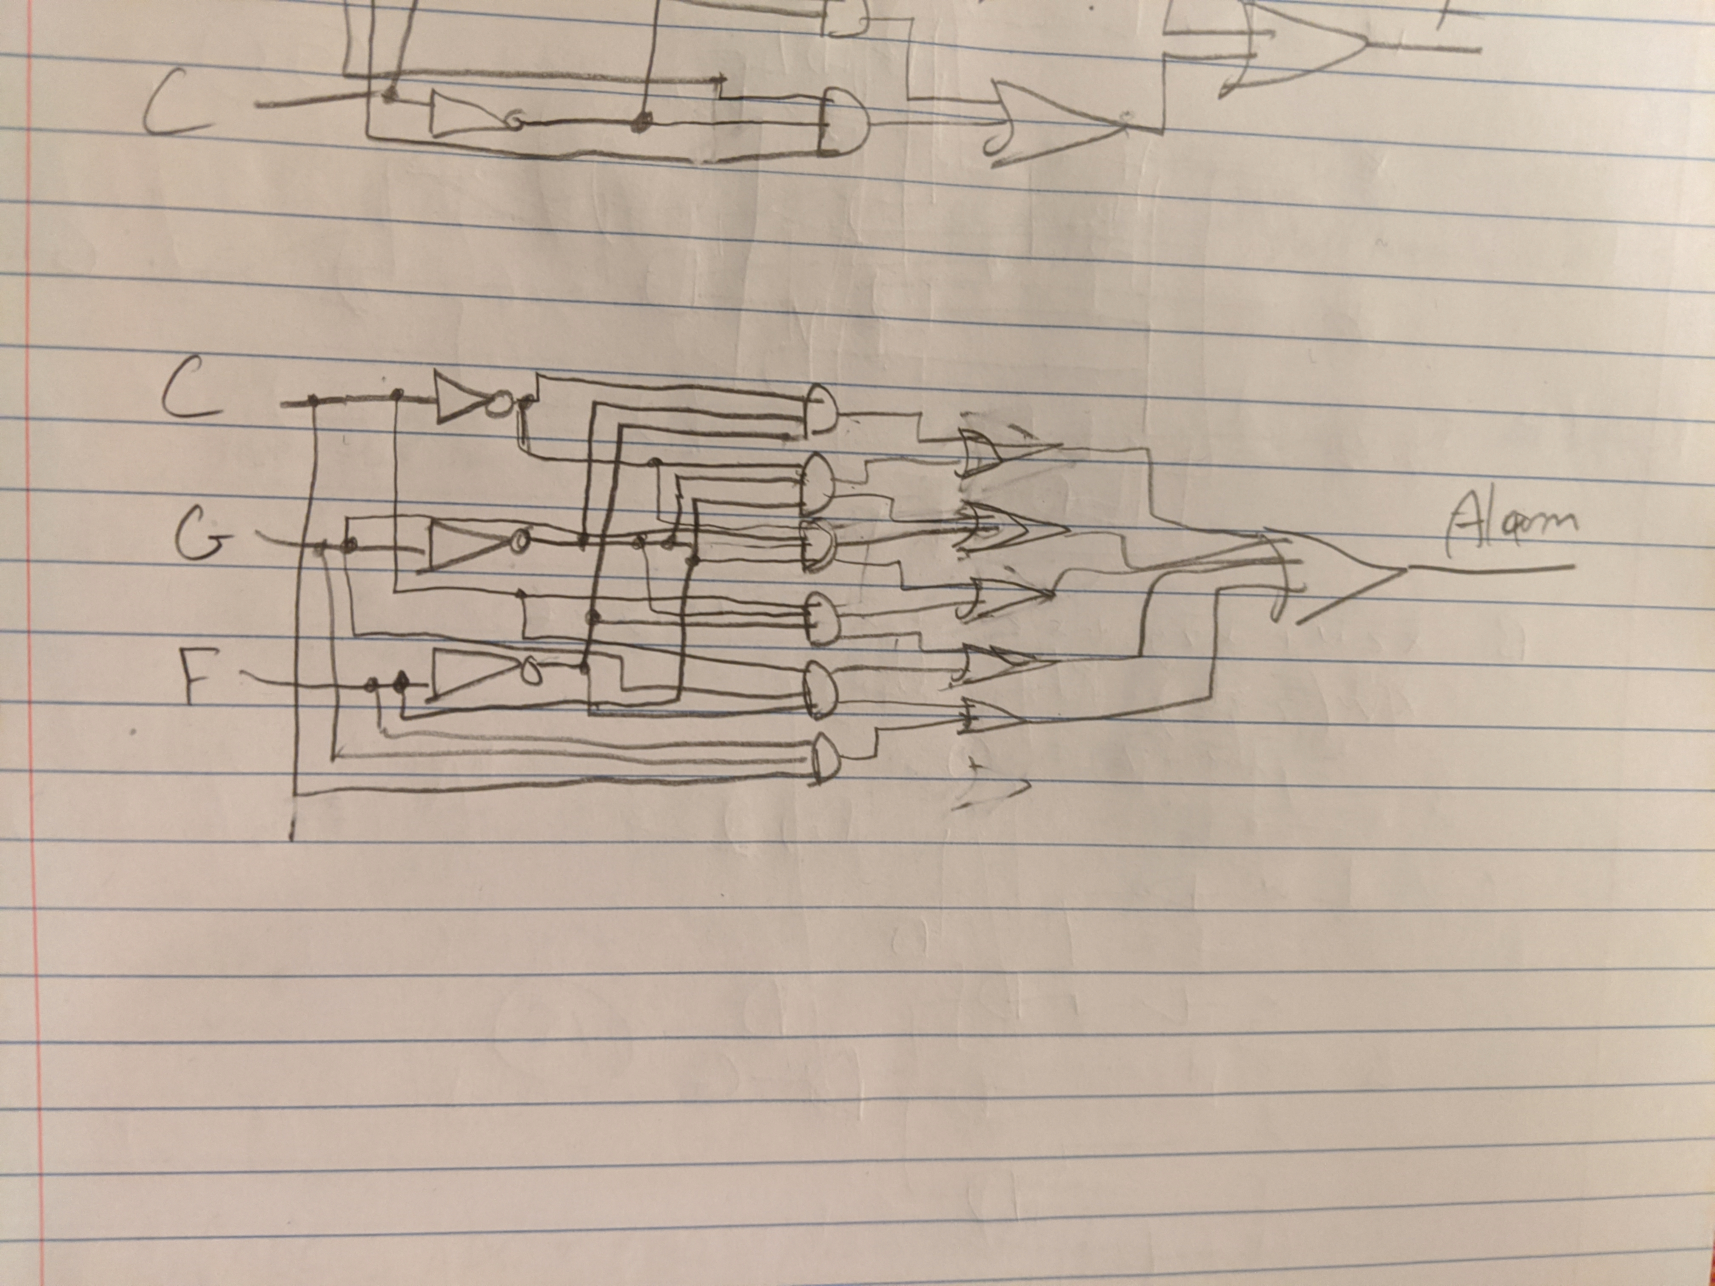

**LAB:**

**3.0** ModelSim results demonstrate a correct circuit.

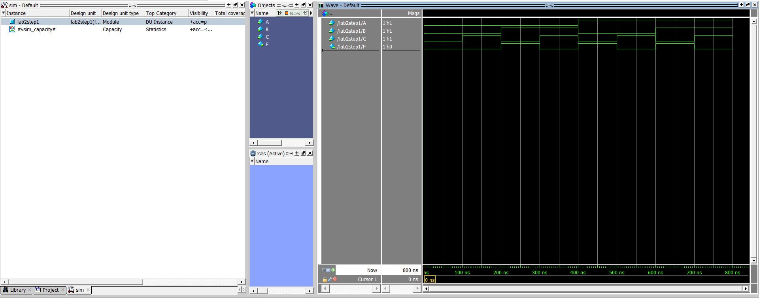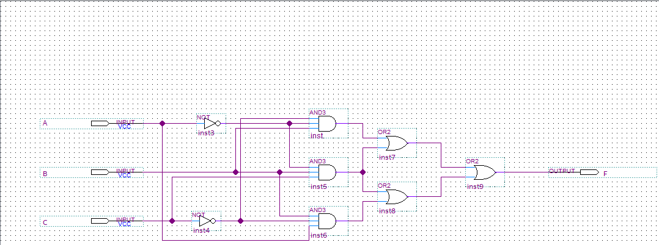

**4.0** ModelSim results demonstrate a correct circuit.

